SIMPLE SELECTORS(no plagiarism daw by Quetext)

1. Universal selector -This selector which is written as (*) matches element to any type.

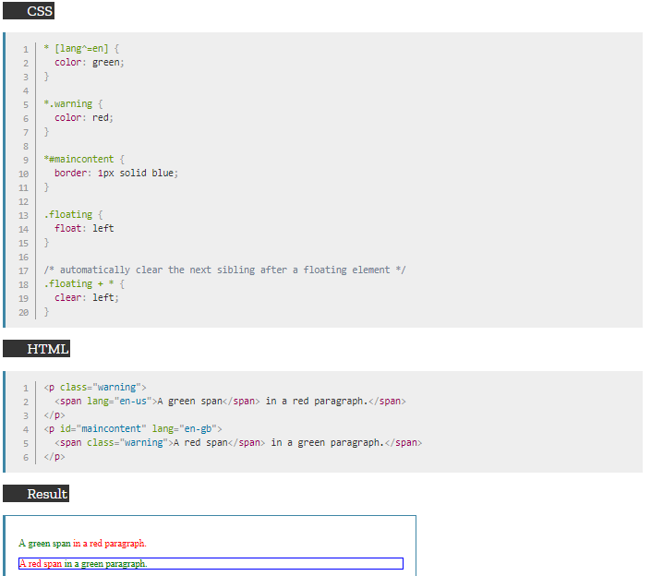

2. Type selector -This allows you to match all element with the same type.

e.g.

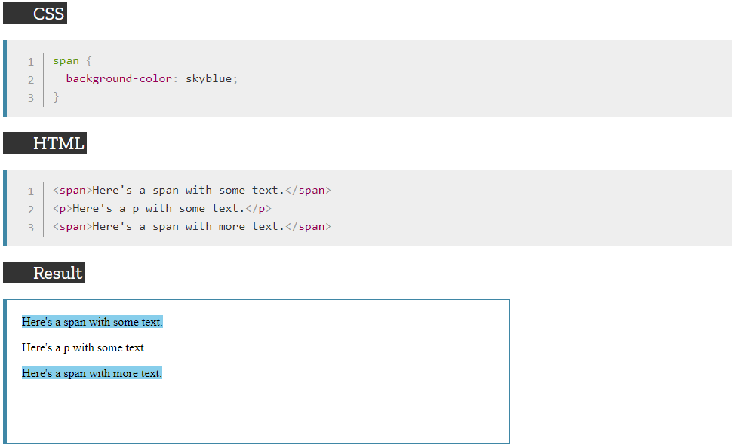

3. Class selector -Checks the content of a class and match them if they have something in common.

e.g.

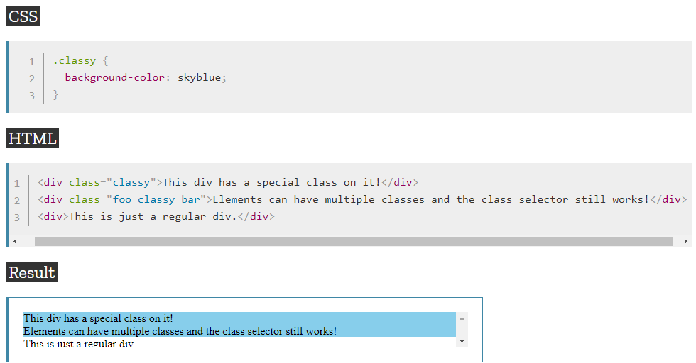

4. ID selector –Just like a class selector, this selector also checks the content of an ID and match them if they have something in common.

e.g.

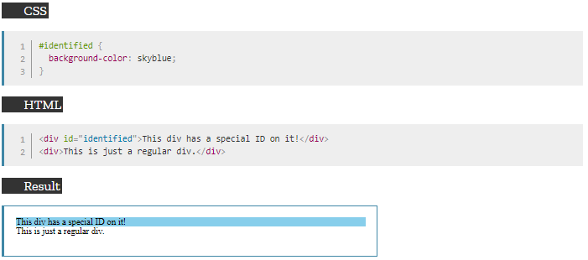

5. Attribute selector –This selector checks the value of a given attribute and matches elements with the same attribute content. 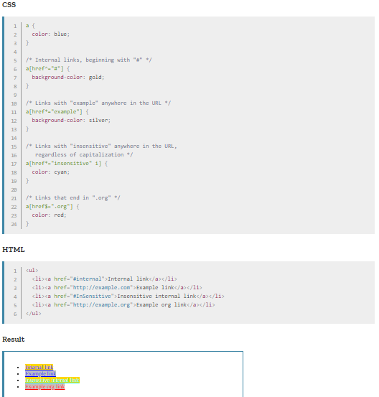

Source: https://developer.mozilla.org/en-US/docs/Web/CSS/Type_selectors